Principles of Modern applications:

Modular – separate functions

Loosely coupled

Separation of Concerns

Common modules for an E Learning Application

eLearning website-  
    so basically considering example of webapp like Udemy the common modules are like :

dashboard  
-- user dashboard  
--admin dashboard

user registration  
  --login  
  --signup

course allotment

feedback section  
-- reviews and rating

payment process  
-- via upi  
-- via net banking

process tracking   
-- attendance of course  
-- test results

notifications  
  -- reminders and alerts

E-LEARNING:                                         
1) Role based User Authentication (Student/Instructor/Org.)  
2) Course Management (Add/edit/delete)  
3) Content Streaming module.  
4) Quiz and Assesment.  
5) Discussion Forum.  
6) Progress Tracking / Analytics & Reports.  
7) Payment Gateway.  
8) Certificate generation and recognition.

E-COMMERCE:  
1) User Authentication  
2) Product inventory Management  
3) User friendly shopping cart interface  
4) Checkout and Payment   
5) Order tracking  
6) Search and Filter  
7) Promotion and Discounts  
8) Review and Rating  
9) Sales analytics (Admin)  
10) Mobile app Optimization

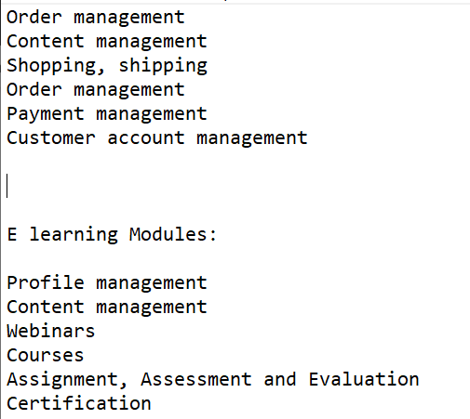

Basic Requirement of E learning

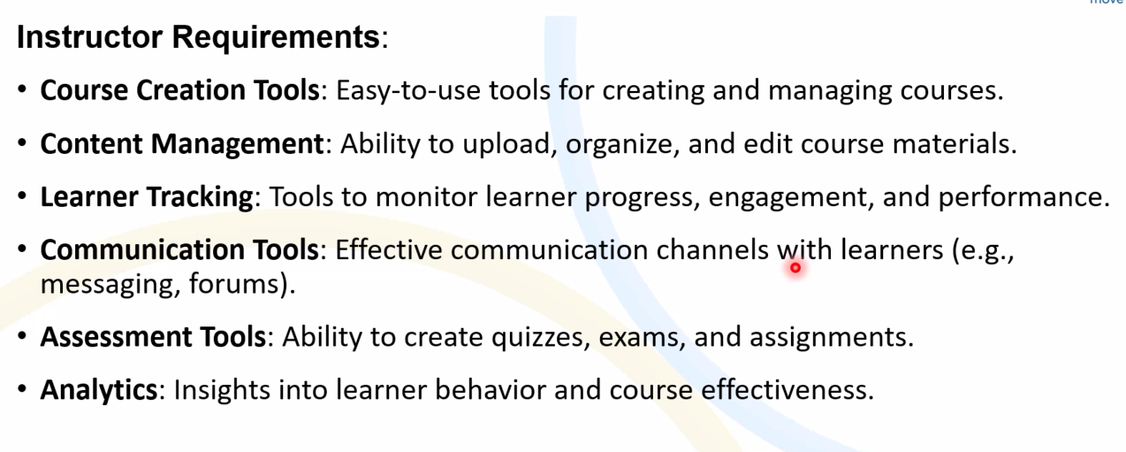

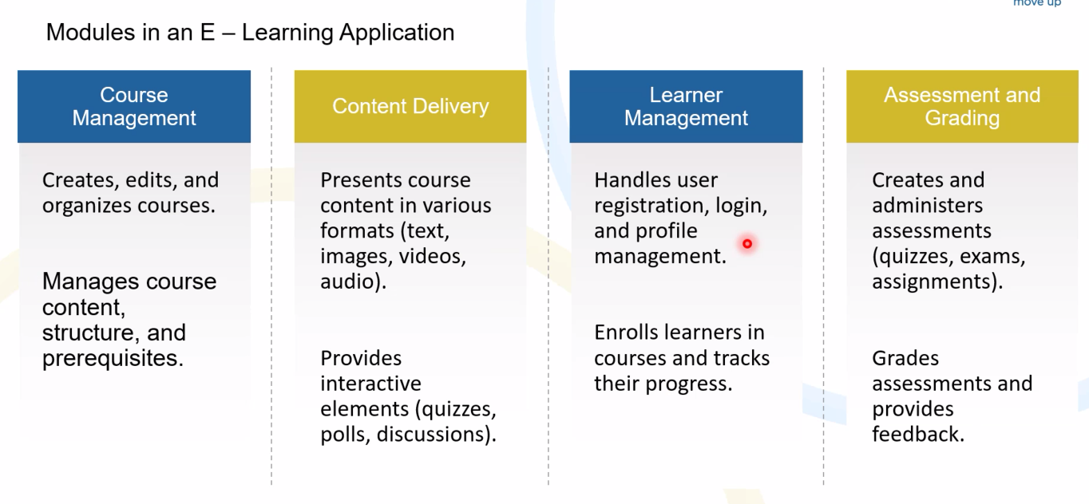

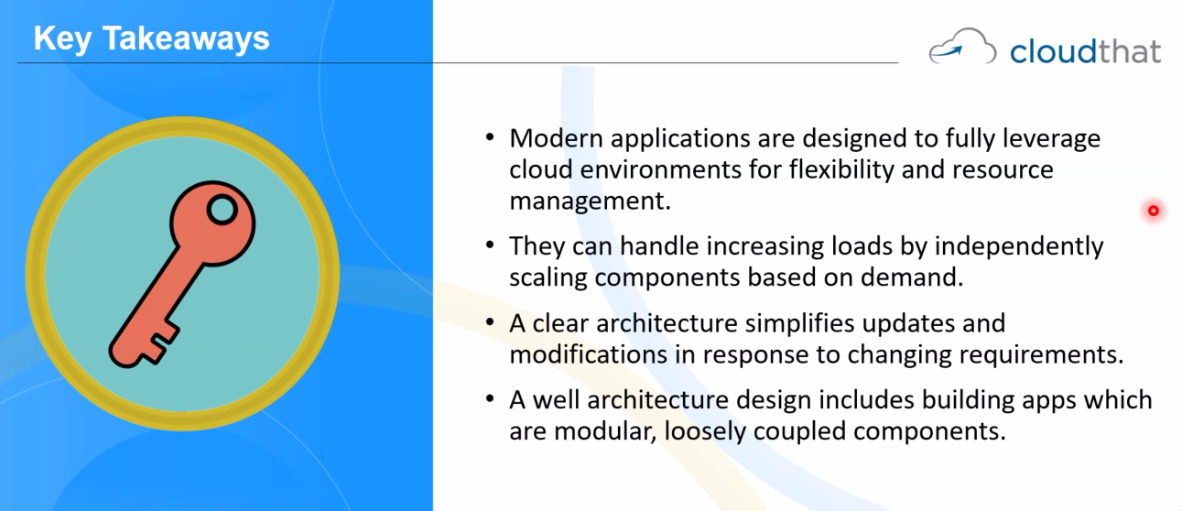

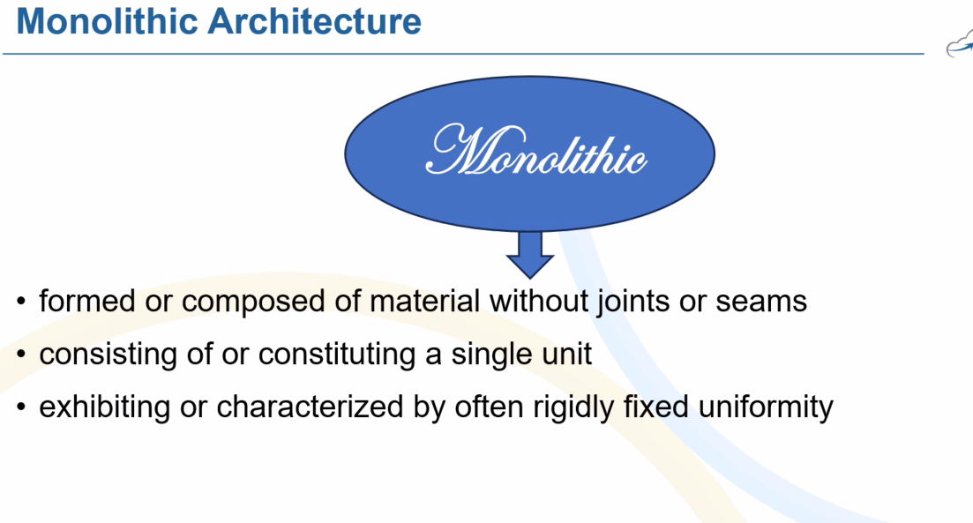

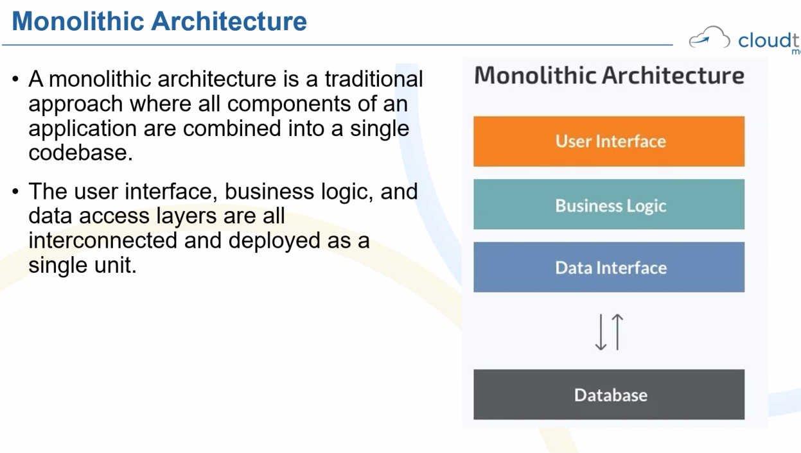

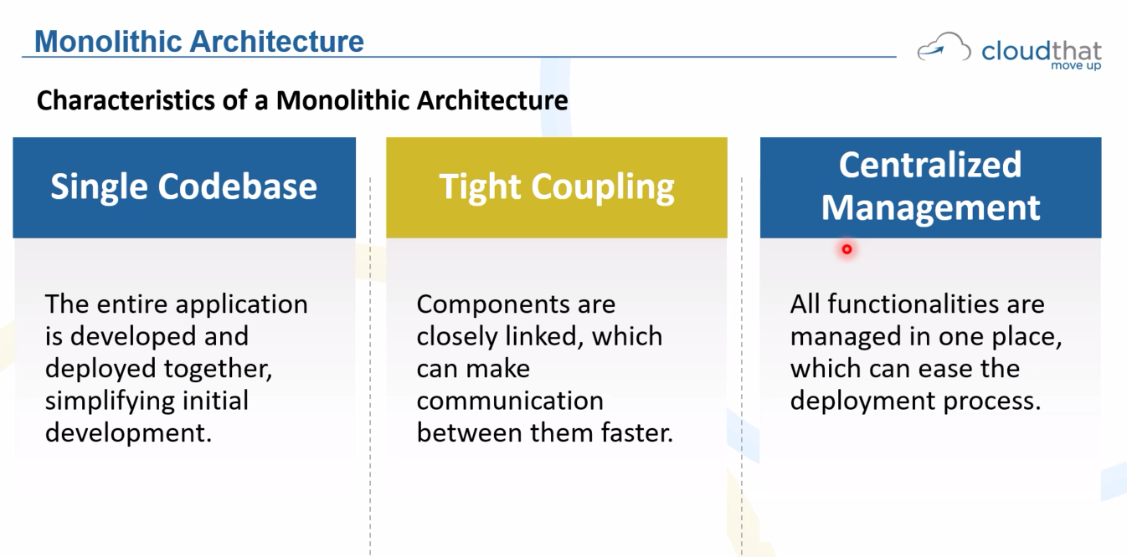

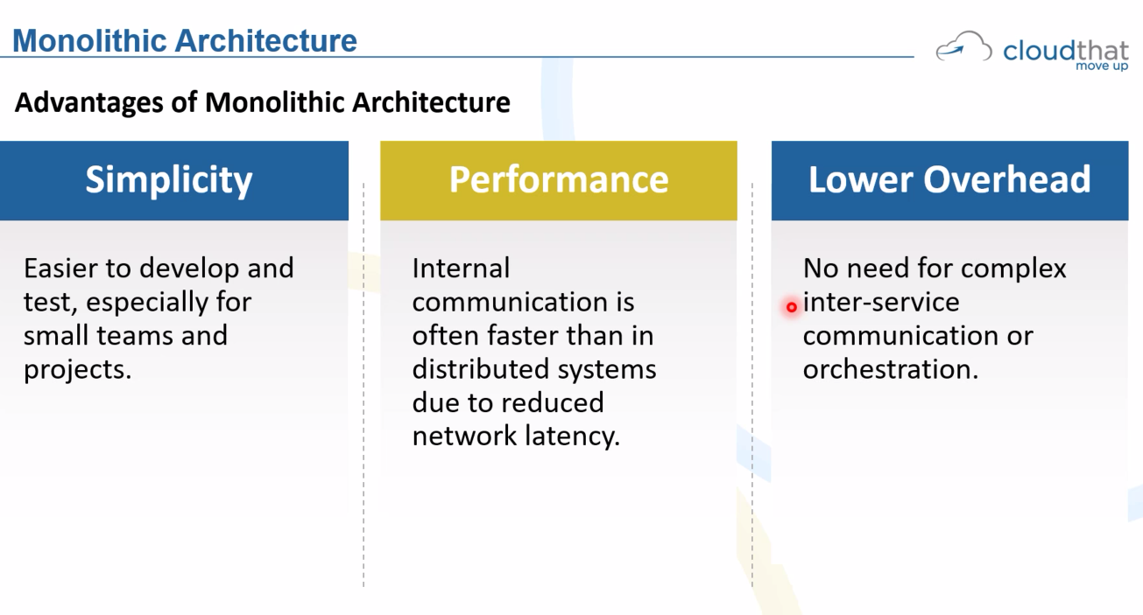

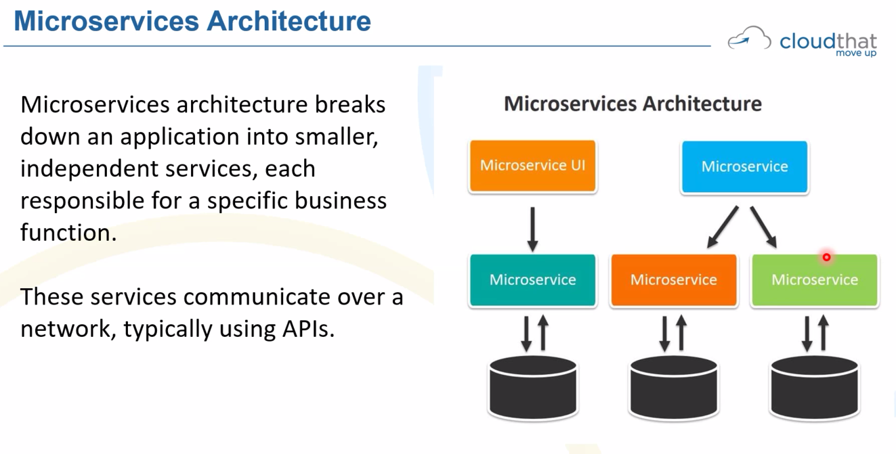

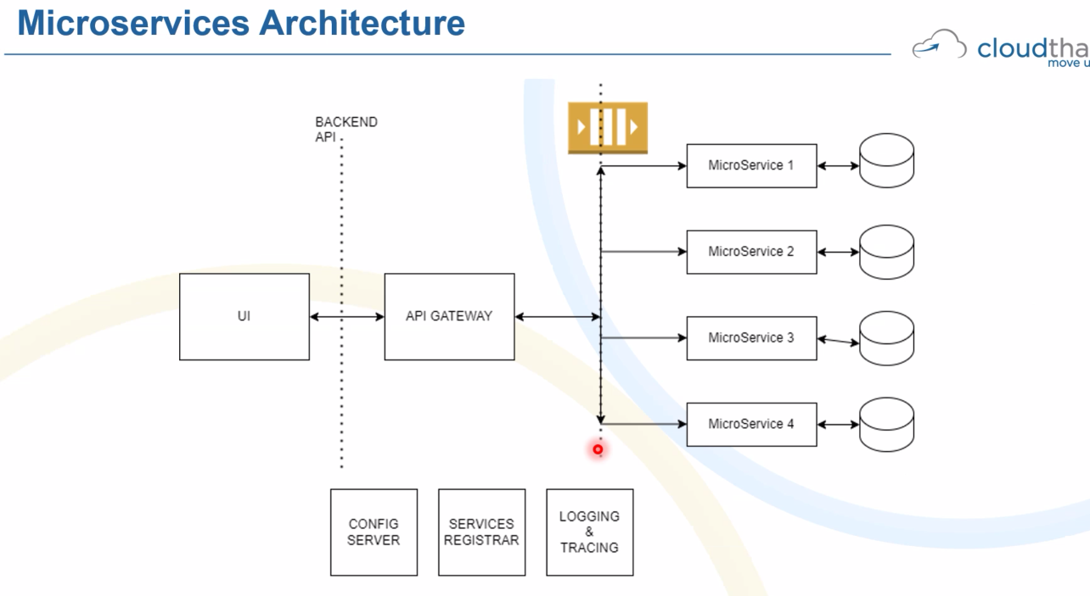

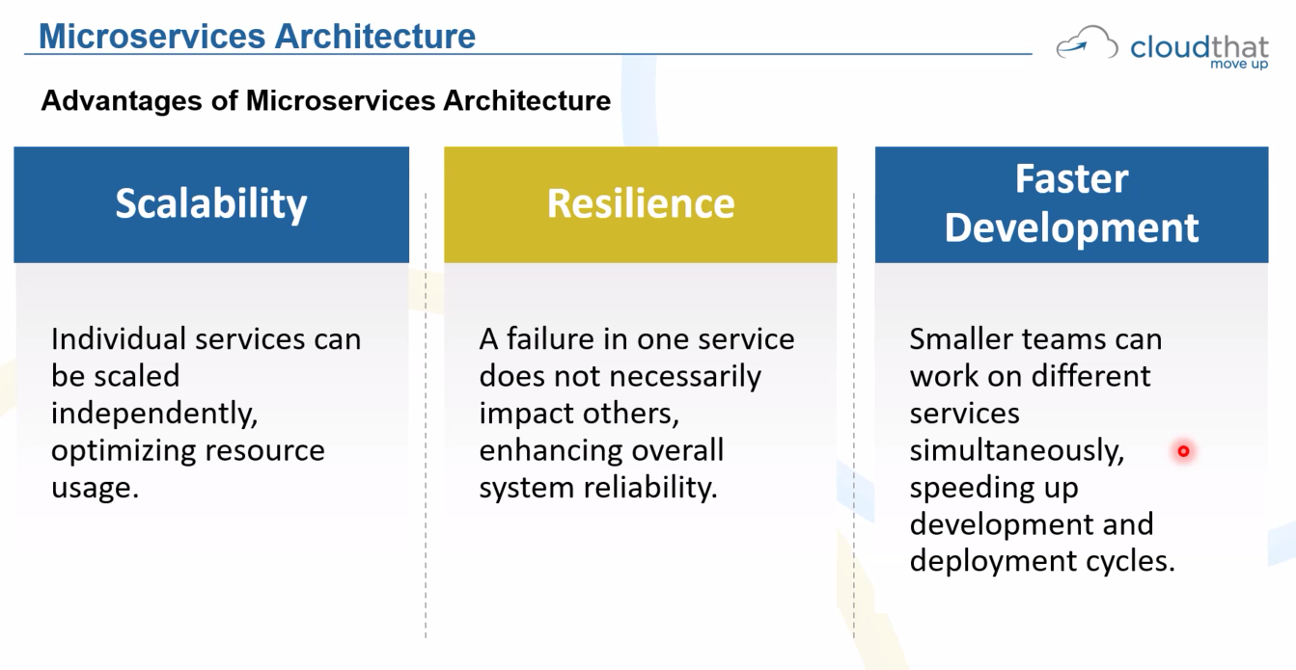

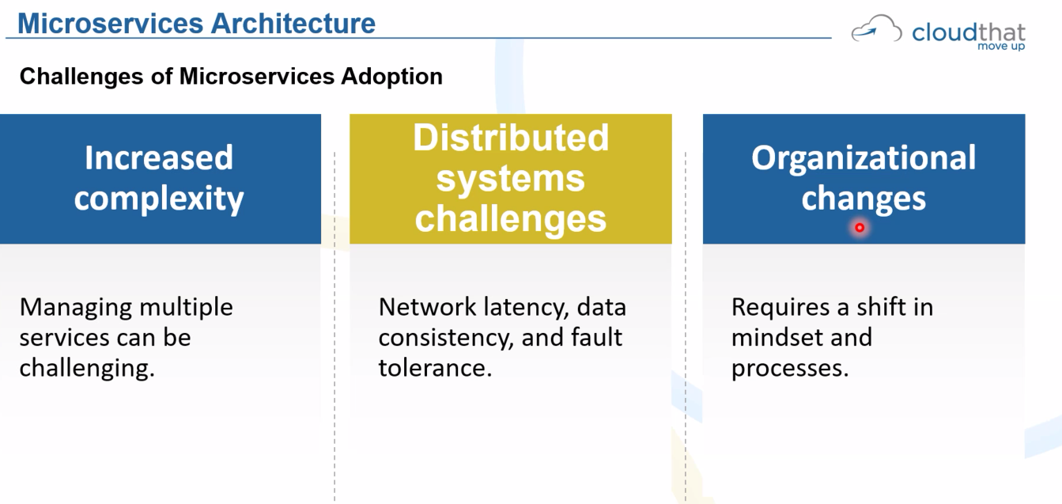

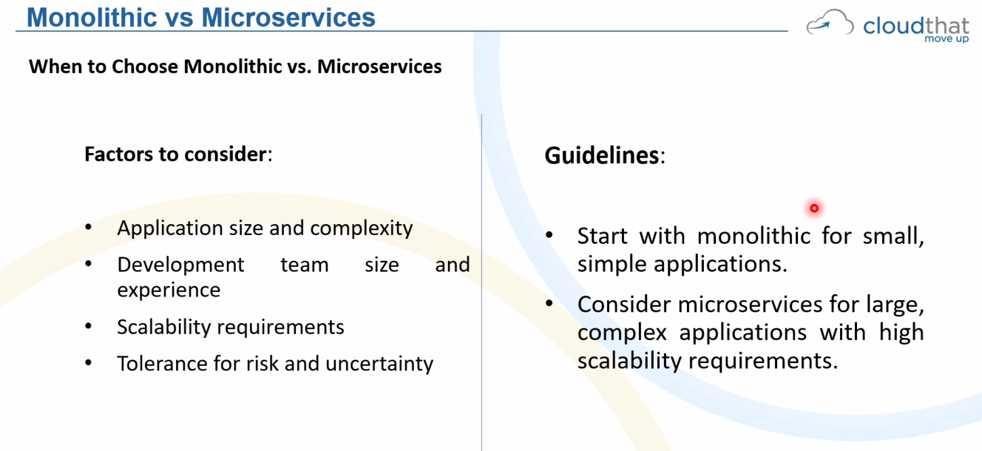

AFTERNOON

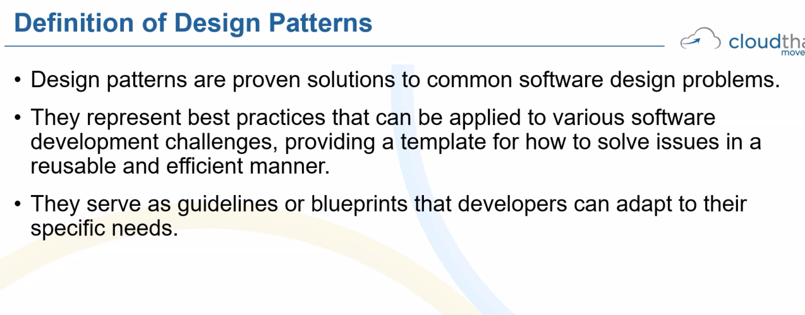

Importance of Design Pattern

Improved Quality

Scalability

Reusability

Standardization

Efficiency

Maintainability

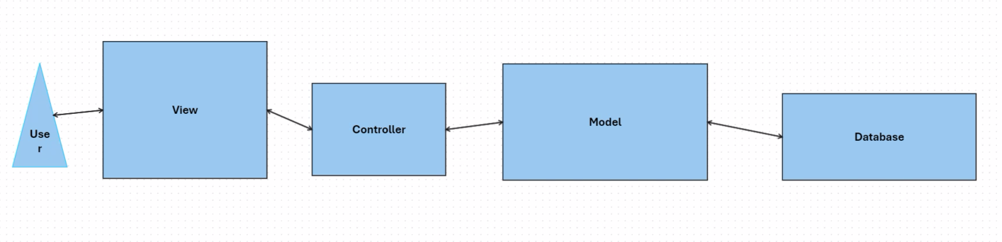

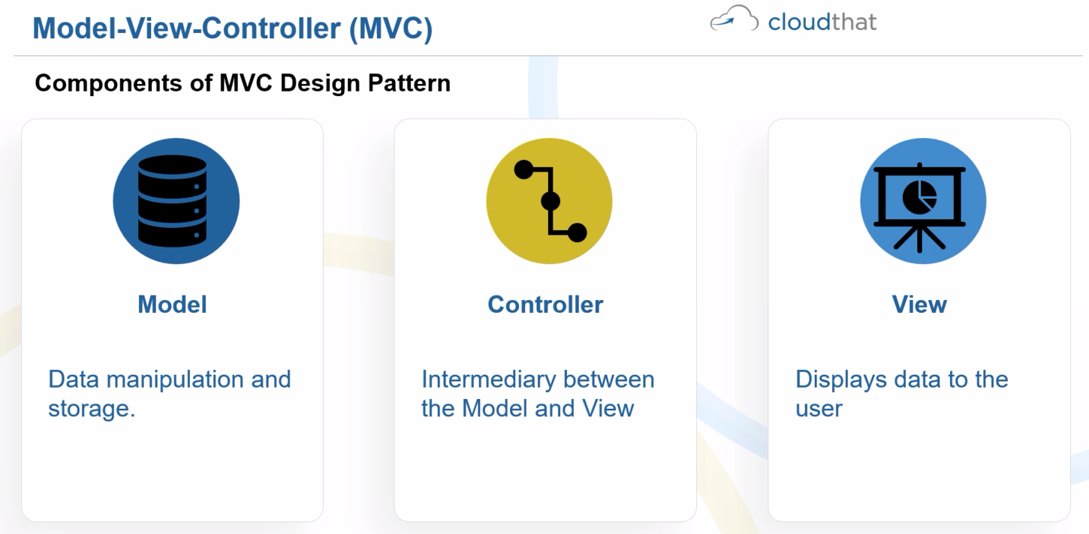

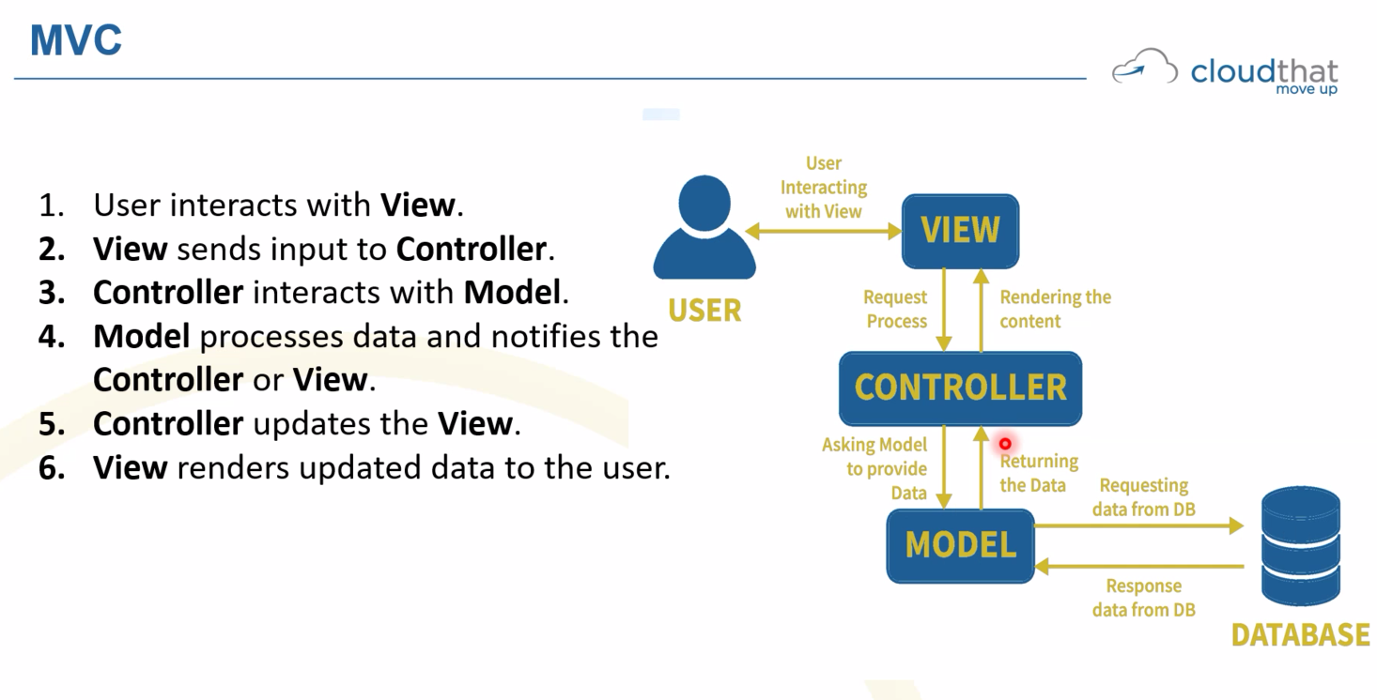

OBJECT ORIENTED PROGRAMMING

Class – Blueprint or a template

In the problem domain what are the nouns

Ecommerce :

User

Product

Customer

Staff

Business

ELearning:

Student

Faculty

Course

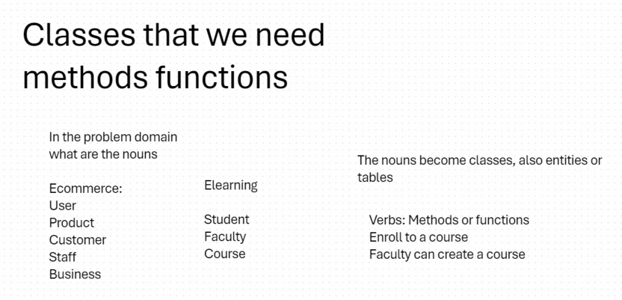

Attributes or properties:

Student: Name, id(rollno unique)

Student Class:

Name

Roll number

Enroll to a course

Register to a course.

UML Diagram – Unified Modelling Language

In a uml diagram we have:

Classes, attributes, methods, private or public, relationships.

